Emergency Action Plan



859 Ward Drive, Goleta, CA 93111

Key Notes
Emergency Response Procedures
In the event of a Life-Threatening Emergency or a building emergency:
- Call 9-1-1
- Give Location Clearly
859 Ward Drive, Suite 200, Goleta, CA 93111
- Listen to directions of 9-1-1 operator(s)
- Ensure the Inogen Safety line is notified: 972-992-7927

- Call the Inogen Safety Line immediately of any emergency situation
- No team member is allowed to re-enter the building during an emergency evacuation until authorized by Safety Officer, emergency personnel, etc.
- All team members are to muster and remain at their designated assembly area until further instruction is given.
- Management will notify the ranking fire or emergency personnel of any potential trapped person(s) and a general area of their location.
- When there is an outside entity working or visiting, their escort is responsible for accounting for them during in the event of an emergency or evacuation.
- Smoking is NEVER permitted during any type of emergency event.

HEAD COUNT PROCEDURES
All team members must:
- Evacuate immediately utilizing the nearest emergency exit doors or route.
- Make their way to their assigned muster point
- Counter(s)- Ensure that all team members are accounted for
- Verifier(s)-Call the Safey Line once everyone is accounted for

Policy
Inogen has developed plans to address emergency situations that may arise at the facilities and which may threaten human health and safety, and damage company assets. Management is responsible for implementing the Emergency Action Plans. These Emergency Action Plans will meet the following objectives:
- Provide a means of notifying employees, customers and local authorities of an emergency situation.
- Provide a safe and orderly method of evacuation of employees, visitors, and
contractors from Inogen premises.
- Account for all employees, visitors, or contractors who occupy Inogen premises at the time of evacuation, should one occur.
- Provide emergency first aid treatment or summon emergency medical assistance for injured individuals.
- Provide training and needed information to those employees responsible for taking action in the event of an emergency.
- Signs as required by ordinance, regulation, or law will identify emergency exits. Employees are required to be familiar with the location(s) of alarm pull stations and emergency exits.
- Training on Emergency Action Plan will take place during new employee orientation, when changes occur in the action plans, and periodically as coordinated by the Safety Department

Purpose
To establish the policy and procedures regarding management’s and employee’s response to various emergency situations. Examples of an emergency are fire, tornado, earthquake, and bomb threat.
Overview:
The procedures cover the following topics:

Emergency Response

Emergency Response Team

Fire Response and Reporting

Emergency Evacuation

Headcount Procedures

Muster Points

Active Assailant/Active Shooter

Tornado Response
- Tsunami
- Earthquake

Bomb Threat

EMERGENCY RESPONSE
If an employee/individual is injured, the initial response is to call 9-1-1 and relay all pertinent information to operator and request emergency medical response or professional medical care. Following the call to emergency services, notify the Safety Officer, Safety Committee Personnel, or First Responder.
Preferred Clinic
Sansum Clinic
5385 Hollister Ave., Goleta, CA 93111
805-681-7781
Nearest Hospital
Goleta Valley Cottage Hospital
351 S Patterson Ave, Santa Barbara, CA 93111
805-681-6473

Injured Individual
- All injured individuals must report their injury to their immediate supervisor.
- Any contractors/visitors that are hurt on-site must report their injury to their assigned escort.
Senior Management/First Responders
- Treat the injured using supplies from first aid cabinets as needed.
- In the event an employee is seriously injured and requires professional medical care.
- If the individual is not mobile or has a life-threatening injury or illness. Arrange for emergency care and transportation. When in doubt call 9-1-1.

FIRE RESPONSE AND REPORTING
If a fire alarm or alert is sounded or a fire is reported by an employee, regardless of the reason for the alarm or the severity of the fire, the following actions must be taken immediately:

Individuals trained and confident in the use of fire extinguishers, may attempt to suppress a small fire, until relieved by the Fire Department, the scene becomes unsafe, or until it becomes apparent that the fire cannot be controlled by fire extinguishers.
Note: Employees should never attempt to control a fire, which endangers their health. You must immediately evacuate the area when it becomes apparent that the fire cannot be controlled or when conditions become more hazardous.
Senior Management of each department
- Immediately notify the Fire Department/Police Department/Emergency Medical by dialing 9-1-1.
- Provides address of Inogen –
859 Ward Drive, Goleta, CA 93111
- Assigns an employee to wait at the facility entrance for the Fire Department to arrive and then to direct them to the location of the fire.
- Safety Manager or Maintenance Manager/Supervisor will be assigned to verify
    - That the Fire Riser Cutoff Valve that supplies water to the sprinklers of the affected area will be locked in the open position.
- All escorts must ensure they account for their visitors or contractors on site at time of emergency.
- After exiting the building, take a headcount of employees to insure all were safely evacuated. Double check that all individuals are out of the facility.

EMERGENCY EVACUATION
This procedure includes, but no limited to, internal fire, gas leak, smoke detection etc. When evacuation is required in the building, it is important to evacuate everyone out of the building in a safe and efficient manner. Team members and visitors are encouraged to familiarize themselves with 2 exits closest to their immediate work area assignment and 1 other exits not in their “usual” work setting.
No team member is authorized to go to their lockers to retrieve any items during a shelter in place.

The following procedures should be followed in the event of an evacuation.
Employees/Contractors/Visitors
- Safely stop all work in your area.
- Proceed to the nearest exit. Do not push or shove anyone while exiting building.
- Proceed to the designated Emergency Assembly Area and account for the employees that were working in your area.
  - After exiting building make your way to the main parking lot for accountability at your assigned muster area.
Senior Management
- Notify local emergency agency (Fire department, police department, hazardous materials team, etc.) The following message must be relayed to all team members.
  - First team member outside will call 9-1-1 and relay all pertinent information to emergency response dispatch.
- Checks all areas of their respective departments, restrooms, and public areas to verify that employees and individuals are evacuated.
  - This should be a quick sweep of the work area. If not safe to do so, do not continue.
- The receptionist is responsible for keeping the Guest Register and for removing that register in case of an emergency.

MUSTER POINT
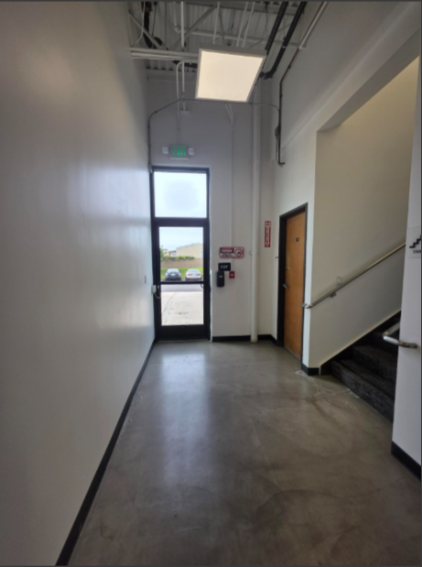
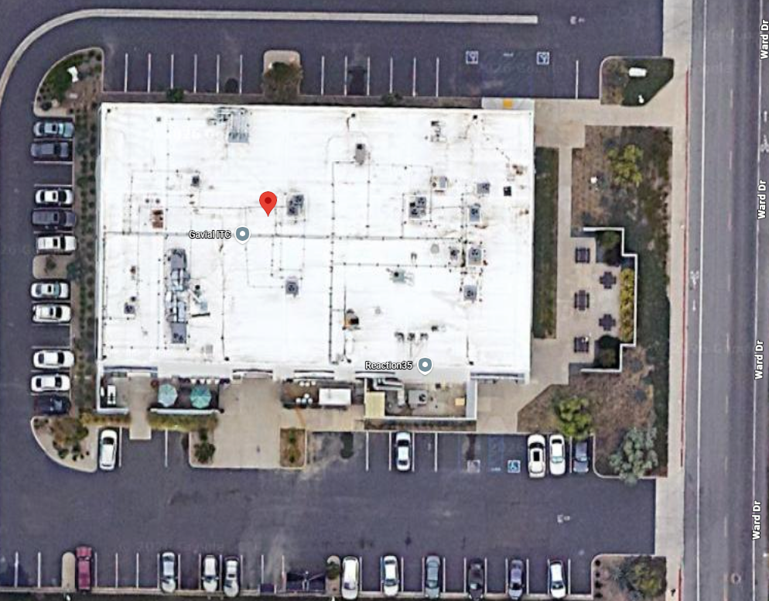

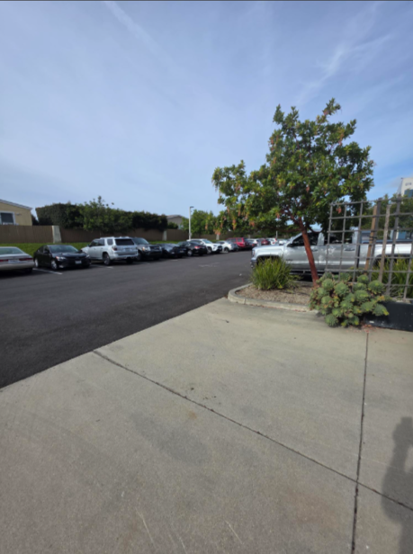
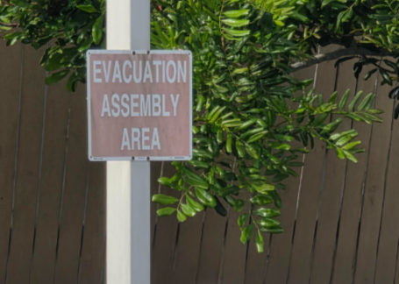
ACTIVE ASSAILANT/SHOOTER
An active assailant is an individual who is engaged in causing physical harm or attempting to kill, people in a confined and populated area. Active assailant incidents are often unpredictable and evolve quickly. Amid the chaos, anyone can play an integral role in mitigating the impacts of an active assailant incident.
In the event of an active assailant:
DO NOT GATHER IN THE ASSEMBLY AREAS.
RUN: Evacuate If Possible
- If there is considerable distance between you and the gunfire/armed person, quickly move away from the sound of the gunfire/armed person. If the gunfire/armed person is in your building and it is safe to do so, run out of the building and move far away until you are in a secure place to hide.
- DO NOT ATTEMPT TO RETRIEVE BELONGINGS FROM LOCKERS, DESKS, ETC.
- Keep your hands visible to law enforcement.
- Take others with you, but do not stay behind because others will not go.
- Call 911 when it is safe to do so. Do not assume that someone else has reported the incident. The information that you are able to provide law enforcement may be critical, e.g. number of shooters, physical description and identification, number and type(s) of weapons, and location of the shooter.
HIDE: Hide silently in as safe a place as possible
- If the shooter is in close proximity and you cannot evacuate safely, hide in an area out of the armed person’s view.
- Choose a hiding place with thicker walls and fewer windows, if possible.
- Lock doors and barricade with furniture, if possible.
- Turn off lights
- Silence phones and turn off other electronics.
- Close windows, shades and blinds, and avoid being seen from outside the room, if possible.
- If you are outdoors and cannot RUN safely, find a place to hide that will provide protection from gunfire such as a brick wall, large trees or buildings.
- Remain in place until you receive an “all clear” signal from Blackboard Connect.

FIGHT: AS A LAST RESORT
- If you cannot evacuate or hide safely and only when your life is in imminent danger, take action. Look for Items that can be used as a weapon. (Fire extinguisher, chair, etc.)
- Attempt to incapacitate or disrupt the actions of the assailant. If you are alone,
- Act with physical aggression toward the assailant.
- Throw items at the assailant if possible.
- Call 911 when it is safe to do so.
Immediately after an incident:
- Wait for Local Law Enforcement officers to assist you out of the building, if inside.
- When law enforcement arrives employees must display empty hands with open palms and obey all commands given to them.
Key Notes
- Understand that gunfire may sound artificial. Assume that any popping sound is gunfire.
- If there are two or more persons in the same place when a violent incident begins, you should spread out in the room to avoid offering the aggressor an easy target.
- Be mindful that violent attacks can involve any type of weapon, not just a gun. Knives, blunt objects, physical force or explosives can be just as deadly as a gun. The suggested actions provided here are applicable in any violent encounter.
- Plan ahead: Visualize possible escape routes, including physically accessible routes for students and staff with disabilities and others with limited mobility

TORNADO/SHELTER IN PLACE
Prior to any tornado emergency, Management will designate safe shelter area within the building for employees and individuals. There are some general guidelines that may be used to aid in the selection of such spaces. Inogen safe shelter areas are the employee restrooms. First aid kits, medical supplies, and flashlights are available in easily-accessible locations when required.

The following procedures should be followed in the event of an evacuation.
All Team Members/Contractors/Visitors:
- Safely stop all work in your area.
- Gather your personal belongings, in your immediate area, if safe to do so - necessities only, in the event you cannot return to the area such as keys, wallet/purse, cellphones and medications, and remember only if it is safe to do so.
  - No team member is authorized to go to their lockers to retrieve any items during a shelter in place.
- Proceed to the nearest Shelter in place location.
- Proceed to the designated Emergency Assembly Area and account for the employees that were working in your area.
  - No team member is to leave the shelter in place location(s) until clear by proper personnel (Safety Manager, Plant Manager, etc.)
Senior Management
Tornado Watch Procedures
- A Tornado Watch means that conditions are right for severe thunderstorms and possible tornadoes to develop. When notified of a tornado watch in the area, Senior Management will tune the radio to the National Weather Service channel to stay current on the storm progress.
- Checks to ensure that all safe shelter areas are unlocked and accessible
- Checks to be sure that medical supplies and flashlights are stored in the safe shelter area
Tornado Warning Procedures
- A Tornado Warning means a tornado has been seen or detected by radar. Senior Management will inform all employees and individuals to take cover in shelter areas immediately.

TSUNAMI PROTOCOL
Santa Barbara and it’s surrounding cities receive Tsunami warnings from the National Oceania and Atmospheric Administration (NOAA) and the West Coast/Alaska Tsunami warning Center (WC/ATWC).
Possible notifications are in the following forms:
- Information, Minor waves- no actions suggested
- Advisory, Strong currents likely- stay away from the shore or inlet(s)
- Watch, Danger level not yet known-stay alert from more information
- Warning, Inundating wave possible-full evacuation suggested
Employee Actions
- Pre-Shift Warning: Is a tsunami warning is issued before working hours begin, employees must not report to work until the was has been officially lifted.
- Warning during working hours: If a tsunami warning is issued, all personnel must be alerted immediately by word of mouth, phone, or whistle. The following procedures apply:
  - If safe evacuation is possible: Follow local emergency instructions. Proceed to higher ground, driving away from the building and toward hills whenever possible.
  - If evacuation is not possible: Proceed to immediately to the roof of the building
- Post-emergency:
  - Medical Emergencies: Contact paramedics, ambulance services, or the fire department if needed.
  - Ensure the Inogen Safety Line is notified of the emergency once the threat has passed. Relay any pertinent information regarding people and building.
  - Gas leak: If you smell natural gas, do not use any electronic device-including landlines, mobile phones, or battery-operated devices. Leave the area immediately and call for help from a safe location.
- Personnel Assistance: Ensure all physically challenged staff and any visitors are assisted through the evacuation process.

EARTHQUAKE PROTOCOL
In the event of an earthquake, the following procedures must be followed.
Before Working Hours
Employees must exercise extremely caution if an earthquake occurs prior to the start of the workday. Before beginning work, carefully inspect your area and surroundings for the following:
- Fallen object, debris, or structural damage
- Spilled liquids or overturned containers
- Cracks in walls, ceilings, or flooring
- Damaged electrical equipment and hanging wires
If any unusual odor is detect, do not enter the building and notify local emergency services as soon as possible.
During Work Hours
If an earthquake occurs while personnel are on-site, everyone must stop what they are doing and immediately move to one of the following safe locations:
- Interior or load-bearing doorway- Stand against the frame and protect your head and neck with your arms.
- Under a sturdy desk or table- Stay away from large equipment, heavy furniture, or anything that could tip or fall. This applies in offices, cubicles, break rooms, conference rooms, and common areas.
- Open interior space- If no desk or doorway is accessible, move away from windows, shelving units, hanging fixtures, and exterior walls. Drop to your hands and knees, cover your head and neck and wait until the shaking stops.
Do not attempt to run outside during and earthquake. Falling debris near building exits is one of the most common causes of injury. Remain in your safe position until the shaking has fully stopped.
After the Earthquake
Once the shaking has stopped, do not immediately assume it is safe to work. Be alert for aftershocks, which can occur after the initial event. The Office Manager should:
- Account for all personnel and visitors on-site
- Conduct a visual inspection of the premises before allowing re-entry
- Follow all established emergency management procedures
- Communicate updates and instructions to all staff clearly and promptly
Employees should avoid using elevators until the building has been formally cleared. Use stairways carefully, watching for damage or debris

EARTHQUAKE PROTOCOL (CONTINUED)
Natural Gas
If you detect the smell of natural gas at any point before, during, or after an earthquake:
- Do not use any electronic device of any kind, including landlines, cell phones, light switches, or battery-operated devices
- Do not turn any lights on or off
- Leave the building immediately, leaving doors open behind you to help ventilate the space.
- Move well away from the building before using any device to call for help.
- Do not re-enter the building until emergency services have declared it safe.
Assisting Others
When assisting physically challenged colleagues, guests, and visitors you must do so in a way that does not endanger yourself. Familiarize yourself in advance with the locations of accessible evacuation routes and any designated are of refuge within the building.
Calling for Help
Contact emergency services-paramedics, ambulance, or the fire department- as soon as it is safe to do so. Provide your exact location, a description of any injuries, and any known hazards on-site. Do not delay calling for help out of uncertainty; emergency responders are trained to assess and manage these situations.

BOMB THREAT
When someone calls and says there is a bomb in the building, the following steps shall be performed:
Employee receiving threat
- Keeps the caller on the line as long as possible. Asks them to repeat the message. Tries to write down every word spoken by the caller.
- Asks the caller where the bomb is located and when it will go off.
- Tells the caller that the building is occupied and detonation of a bomo could result in the death and injury to innocent people.
- Pays particular attention to background noises, such as music playing, kids in the background, engine noises, etc.
- Listens to the voice to identify gender, voice quality, accent, speech impediments.
- If the caller hangs up, DO NOT HANG UP THE PHONE! Sometimes, phones can be traced back to the source.
- Immediately notify management and describe the threat.
Senior Management:
- Calls the local authorities to report the incident. Follows all recommendations and guidelines provided
- If no instructions are given, search the premises for any suspicious devices or packaging.

